**Checkpoint (2): App Requirements and Design**

UML diagram:

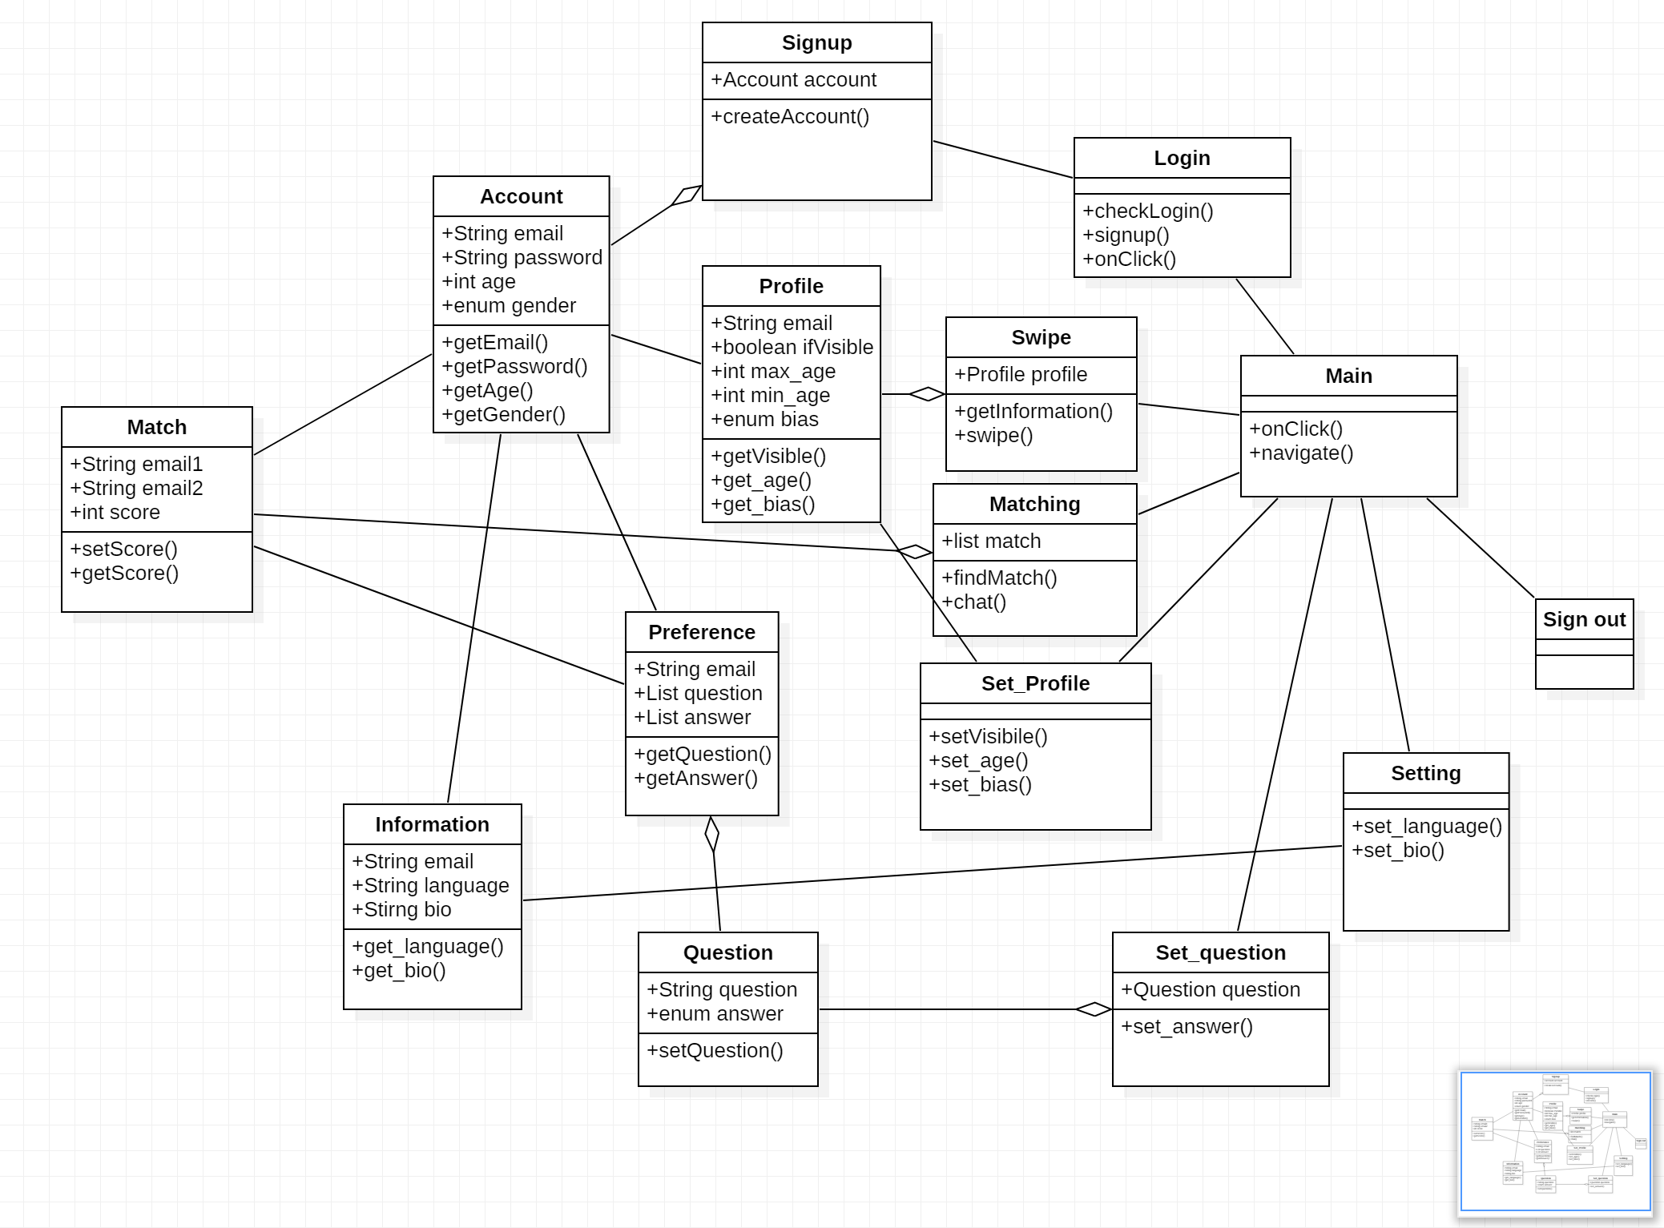

Relational Model:

Database design:

Tables:

User { email varchar(255), (primary key)

password varchar(20),

age int,

gender enum, }

Profile { email varchar(255), (primary key)

photo longblob,

visible boolean,

min_age int,

max_age int,

bias enum,}

Information{

email varchar(255), (primary key)

language varchar(20),

bio varchar(255),

}

Question{

email varchar(255), (primary key)

question_1 enum,

question_2 enum,

question_3 enum,

question_4 enum,

question_5 enum,

question_6 enum,

question_7 enum,

}

Match{

email1 varchar(255), (primary key)

email2 varchar(255), (primary key)

email1_match boolean,

email2_match boolean,

score int,

}

ER Diagram

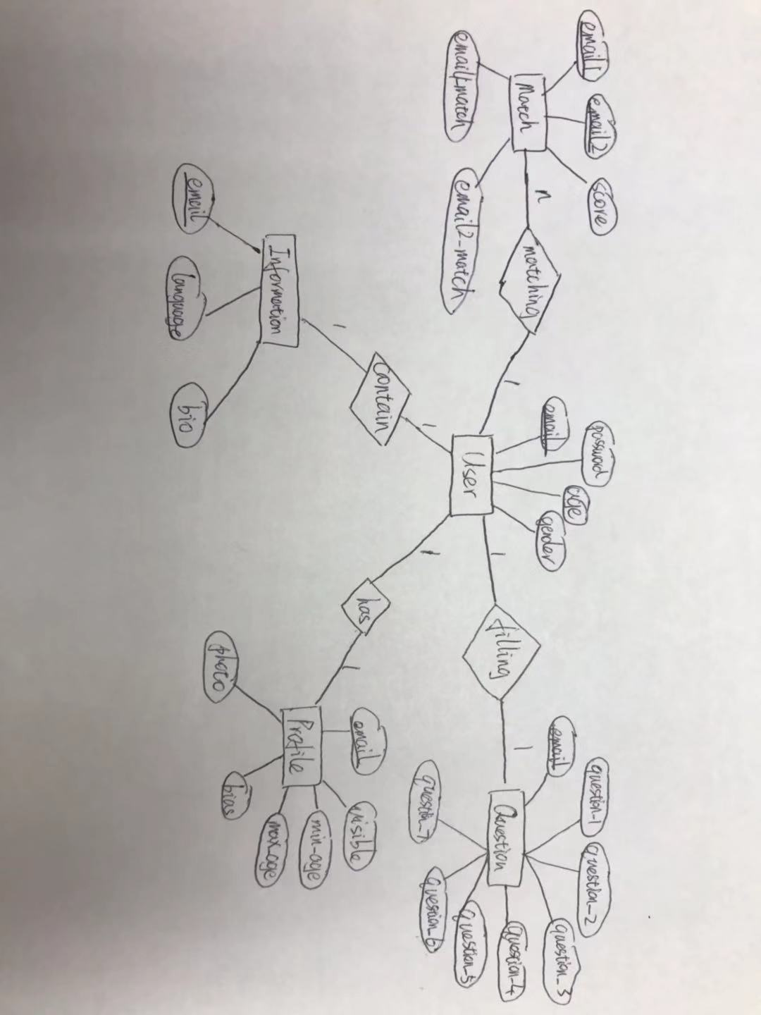

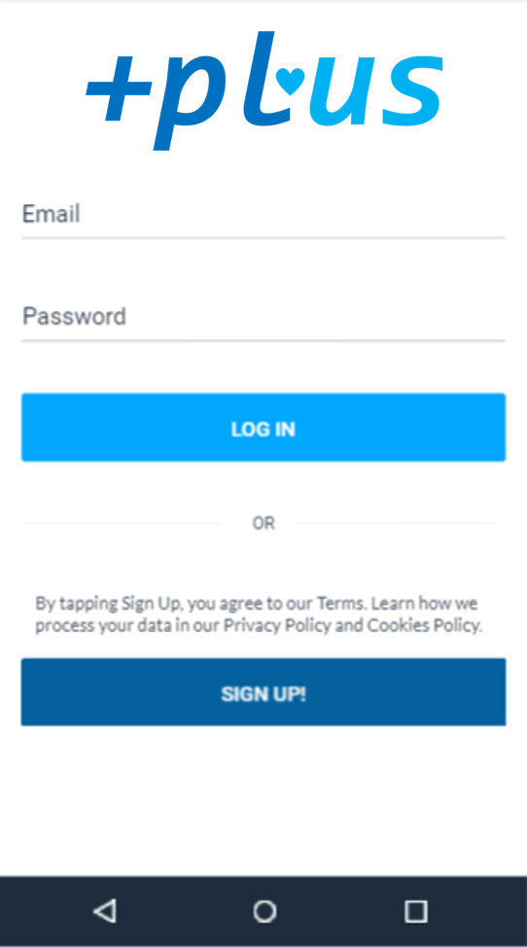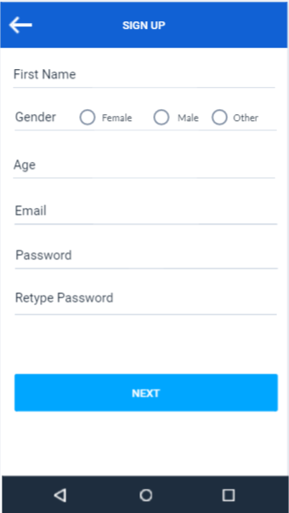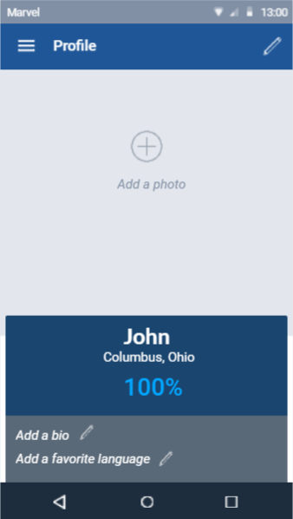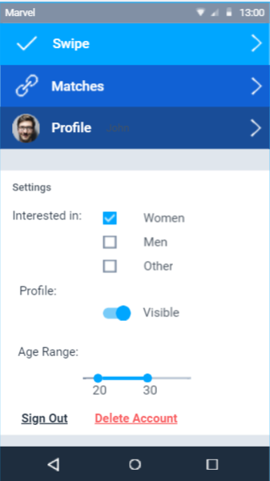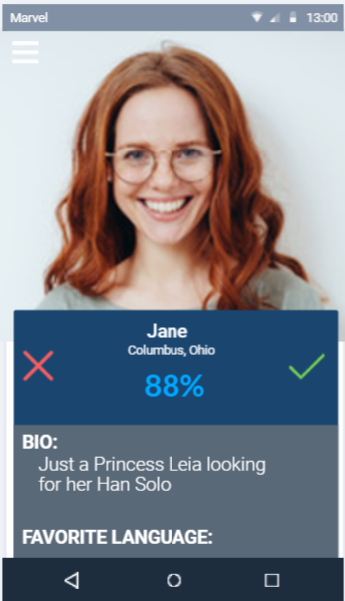

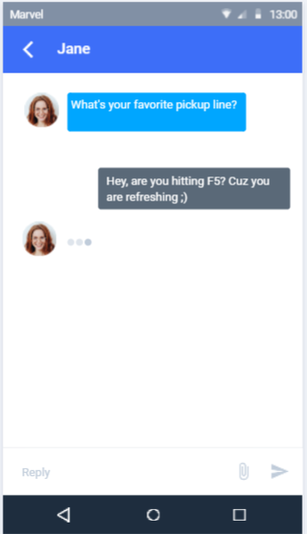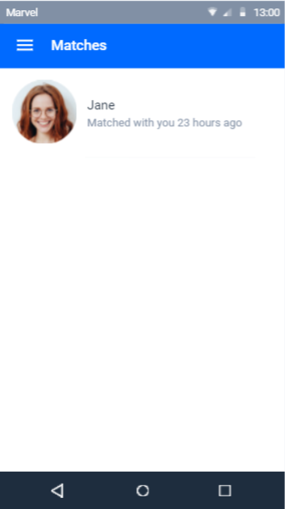

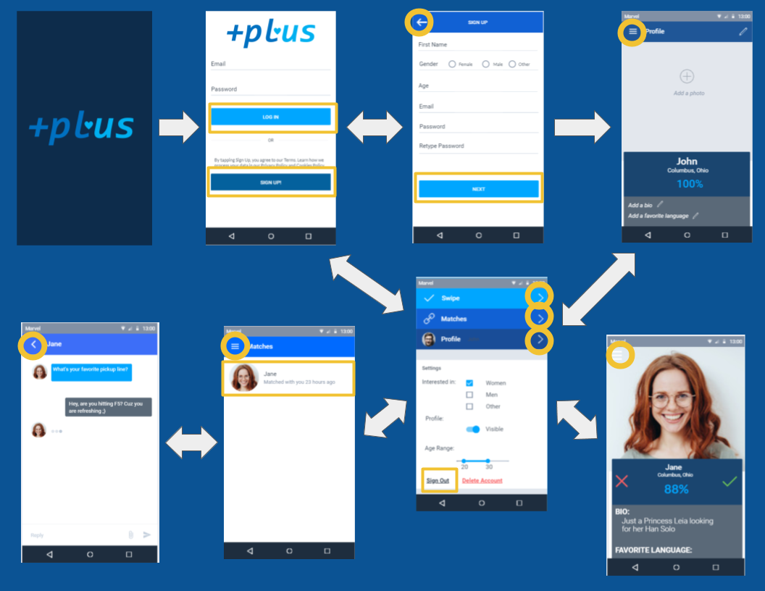

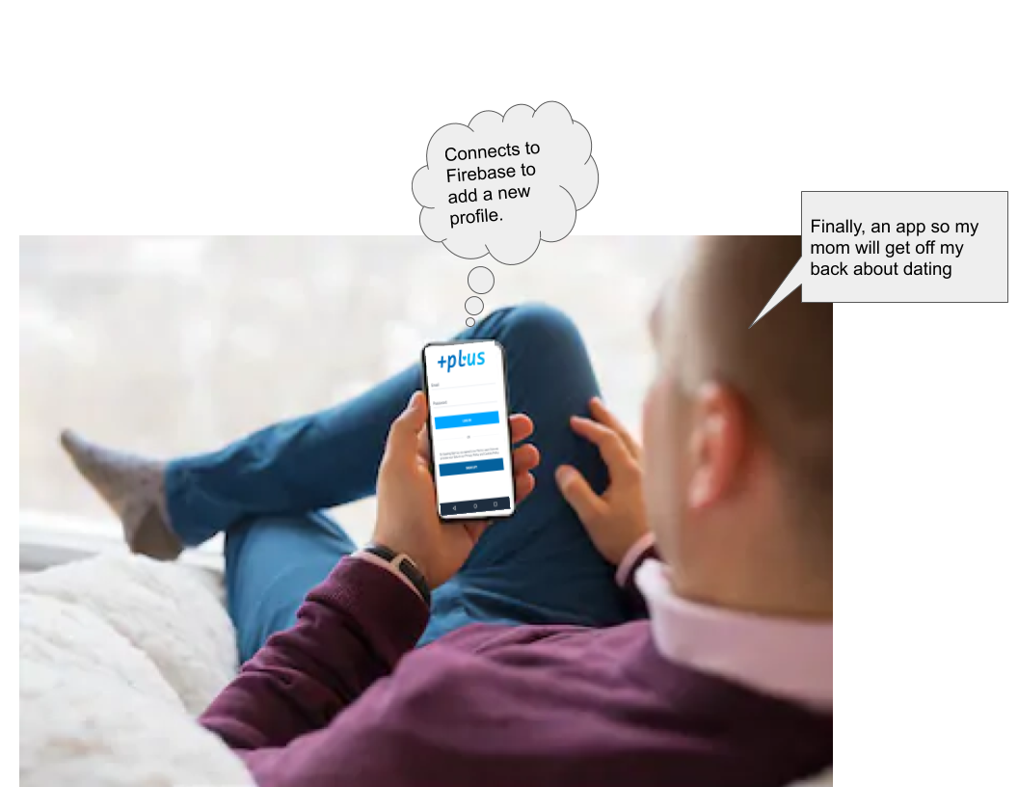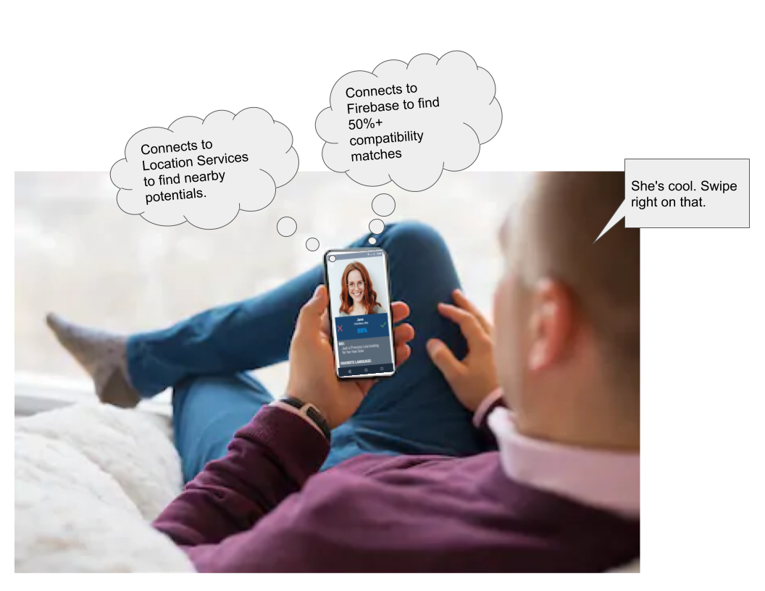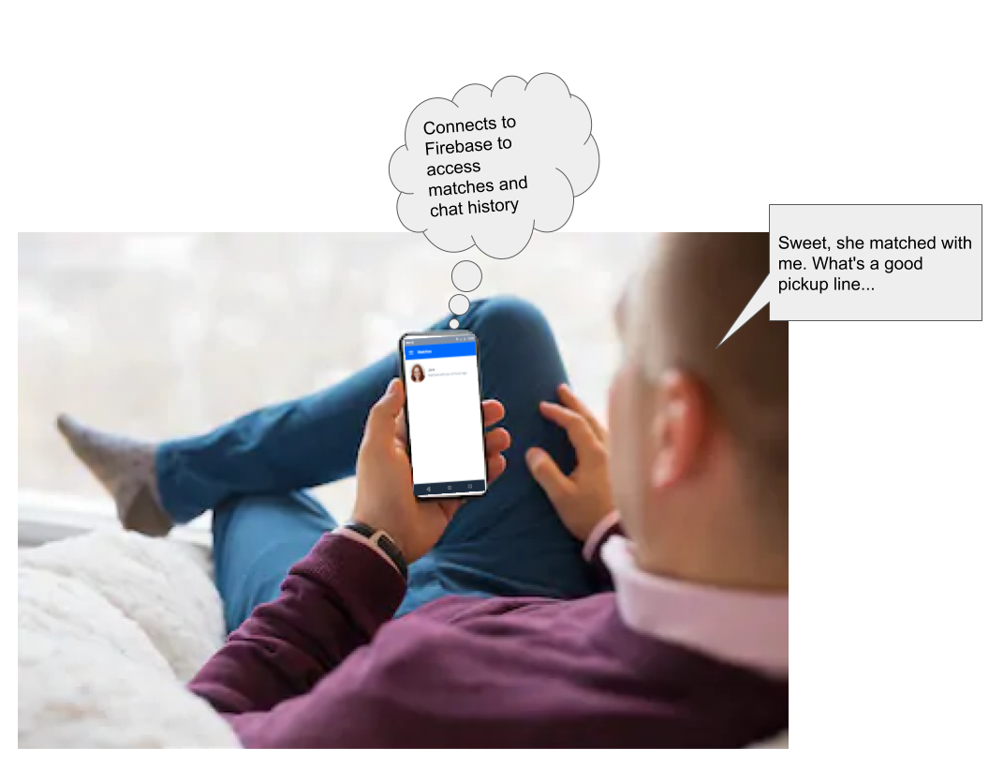

Narrative:

As the world turns more to an online presence than ever, fewer people are finding love without the help of their trusty wingman. Many people are meeting their significant other with the help of their phone and a dating app. For those individuals who have a love for computer science and are seeking another love, +plus will connect them to other coding enthusiasts.

Students will be able to start by signing up for the app, followed by answering a few questions about themselves, including some coding preferences. After signing up and answering enough questions, a compatibility score with several others in the area will be produced, and the top few matches will be shown to the user. The user can then initiate a conversation with any of these other users. If the user would like, they can also go through a more elaborate list of matches or answer more questions to get a better list of matches.

Use Cases:

A. Account Creation:

1. When user presses the ‘sign up’ button they should be able to create an account by providing their name, gender, email, and password
2. If the user has an account and inputs the matching email and password they should be signed into their account and redirected to the homescreen of the app, otherwise they will receive a message that the email/password combination used is invalid

B. Account Management:

1. When the user signs up, they should be able to set up their profile by doing things such as adding a profile picture and answering questions about themselves
2. When the user logs in to an existing account they should be able to answer any unanswered matchmaking questions
3. When a logged in user presses the profile banner, they will be redirected to the edit profile where they can update preferences/information relating to their account

C. Swipes

1. When the user is on the home screen and clicks the swipes banner they should see a quick view of another user’s profile (pulled from the match list) with a compatibility %.
2. If the user (A) decides they are a match, they will swipe the green checkmark and the boolean email1_match (or 2) will be set to true.
3. If the user decides they are not a match, they will swipe the red x and that match will be deleted

D. Matching

1. When the user is on the home screen and clicks the matches banner, they should see a graphical list of any users that share a match with them (same emails in a match and both have the boolean set to be true in the match)
2. When the user clicks on the banner of a profile in the graphical list, they will be directed to a chat with that user